Custom Export

Initial Testing Checklist – Technical Consultant
Quorum Federal Credit Union

Export Name: EBC COBRA NPM
Prepared by: Darren Collard

The following contains the minimum tests that should be run in an Ultipro database prior to the export being released to the Quality Assurance Analyst for testing. Even when using a pre-approved template, the below steps need to be followed as the customer specific specification may include differences from the template. Please refer to the QA Testing Guide for more detailed information and how-to's.

 | Test | Description | Notes
 | Session Validation | Notate the sessions that were created on the Notes section for the interface in BackOffice and/or .Net (ex. ONDEMAND, Test, etc.) | 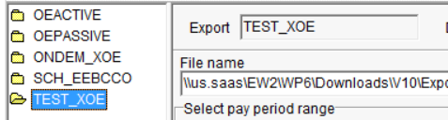
 | File Creation | - Export is executable from the employee history export screen and file has been generated and sent to its intended destination.  - Ensure correct file type extension | 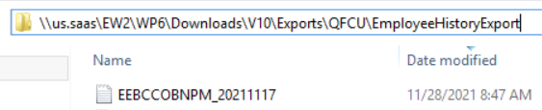
 | File Layout | - Compare the field start and end to file specification.  - Ensure Field Lengths, Start Pos, and End Pos matches the File Width.  - Ensure correct delimiters are used  - Ensure the delimiter is either remove or encapsulate in double-quotes if delimiter is in field value.  - Ensure that any columns showing blank/no data match file specifications
 | Formatting | - Make sure all formatting requirements are followed per Specification  - Dates  - Amount Fields  - Phone Numbers/Zip Codes  - Zero Padding, etc…
 | Sort Order | If your export has required sort order records:  - Ensure the records are listed in the correct sort order.
 | Header Record | - Verify the format of the header record.  - Verify any dates or calculations in the header record.
 | Trailer Records | If there is a total record:  - Make sure the totals and counts are coming out.
 | Data Collection | - Ensure the accuracy of the data elements against the selection criteria identified in the specification.  - For example, if a specification states to exclude terminated employees, ensure that no terminated employees are presenting on the file output  - Confirm row counts for Full versus Changes only files  - For Deduction Code based files:  - Confirm system counts against file output | To provide changes only, the export is filtered to include rows where BdmBenStatusDate between @StartDate and @EndDate.
 | Data Validation | - For Contribution based files:  - Provide Control Totals per Specification Groupings  - Provide per controls used in Validation process  - For Non Contribution based files:  - Report employees who fall out of provided mapped values/scenarios included within file Specification  - Ensure that no values are passing prior to any defined minimum start date  - Ensure that any columns showing blank/no data match file specifications

Delete any items below that do not apply directly to your integration build:
- Any logic that uses date information is using the @EndDate variable and not getdate()
- Any logic which references plan years is doing a dynamic creation based on @EndDate and not hard coded to a specific date
- Any export which uses an INSERT INTO statement into a table which was created using a previous SELECT INTO has its varchars defined with enough space in the SELECT INTO to prevent truncation errors
- For large ENT customers run time for imports needs to be considered as these tend to time out during year-end updates due to the large amounts of data which need to be processed
- Make sure any SQL based FSA enrollment exports are using an Active OE session and not passive in cases where only one OE session is supplied
- UCN - Filenames for OE files which are needed for certain vendors
- UCN - Production flags and send to vendor flags are checked for OE sessions and not just the regular session
- UCN - Future dated stop dates are set with an adequate window (30 to 45 days) in cases of audit based term reporting
- UCN - Make sure all appropriate sessions are added to web portal: Regular, Test, OE Active Send, OE Active No Send, OE Passive Send, OE Passive No Send
- Make sure all files which need to have OE sessions have those sessions available to the customer either on the web or in back office
- Set the “Interface Descriptions” on the web to something which is easily understandable by customers. Often times this is set to the format code or some other internal code that a customer would never understand.
- Make sure any OE files that run via UDES have the transmission rule set up in a way to allow the OE file to send to the vendor. The OE file name often contains OE in the name and does not transmit.
- When testing is done on a new integration, if a test server was utilized during development and a file should be going to a different server from what was used during testing, that this is handled appropriately
- When integrations are put into production during October – December time frame, ensure client is given the choice to add the new year’s OE changes during the course of the project.

Backup Screenshots can be pasted here:

